MATH 1132Q – Getting Started
Hey everyone, Lucien here! In this introductory guide, we will summarize the topics presented in Calculus II, learn about what makes this course different from other math courses, and review material that you may need to commit to memory going into the class. Don’t worry though! Learning this material now will make the class feel like a breeze later on and will be a useful tool to have in your mental library for future calculus courses to come.
Let’s get started!

General Scope of Calculus II
Calculus II is very different from Calculus I. While Calculus I focuses on derivatives and the basics of integration, Calculus II focuses on integration techniques, infinite sequences and series, and parametric/polar calculus.
Here’s the course outline for MATH 1132Q:

Module 1 - Integration Techniques
Module 1 is often regarded as the most difficult module for most students since it is so memorization-heavy and includes Exam 1 content. However, with enough practice the correct resources you will discover that it is not so bad!
7.1 Integration by parts
7.2 Trigonometric integrals
7.3 Trigonometric substitution
7.4 Integration by partial fractions
7.7 Approximate Integration
7.8 Improper integrals
6.4 Work

Module 2 - Sequences & Series Basics
This module will set the foundation for the rest of the course that involves series and it is extremely important that you fully comprehend it. Yes, it may seem like a lot, but it will become second nature once you advance to the next section.
11.1 Sequences
11.2 Series
11.3 Integral test
11.4 Comparison tests
11.5 Alternating series test
11.6 Ratio & Root tests

Module 3 - Taylor & Power Series, DE’s
This is the brunt of Calculus II and, at least to me, the most interesting part. It introduces the final topics on series and is where all of your knowledge on series tests comes into play. It also touches briefly on DE’s—useful in the future if you plan on taking MATH 2410!
11.8 Power series
11.9 Power series representations of functions
11.10/11.11 Taylor series with applications
9.1 Intro to differential equations
9.3 Separation of variables

Module 4 - Parametric and Polar Calculus
Module 4 takes a much-needed break from series and explores topics that you will encounter later if you plan on taking MATH 2110Q and related courses. In my opinion, this module is the easiest and its content should serve as easy points on the final.
8.1 Arc length
10.1 Parametric equations
10.2 Parametric equations with calculus
10.3 Polar coordinates
10.4 Area in polar coordinates

Things You are (Unfortunately) Expected to Know Going into Calculus II
- Trig Identities – Save this file, copy them down, do whatever you need to keep them handy!

Pythagorean Identities | $\sin^{2}+\cos^{2}$x = 1  1 + $\tan^{2}x= \sec^{2}x$  1 + $\cot^{2}x= \csc^{2}x$
Double Angle Identities | sin(2x) = 2sinxcosx  $$cos(2x)={cos⁡}^{2}x-{sin⁡}^{2}x \\ cos(2x)=2{cos⁡}^{2}x-1 \\ cos(2x)=1-2{sin⁡}^{2}x$$
Power Reduction Identities  (very important for trig integrals) | $$\sin^{2}x= \frac{1-cos⁡(2x)}{2}$$  $$\cos^{2}x= \frac{1+cos⁡(2x)}{2}$$
Reciprocal Identities | $$tanx= \frac{sinx}{cosx}$$  $$secx= \frac{1}{cosx}$$  $$cscx= \frac{1}{sinx}$$  $$cotx=\frac{1}{tanx}$$

- Special Derivatives – A few of these you may never encounter, but they are good to know!

Function | Derivative
$$e^{x}$$ | $$e^{x}$$
$$a^{x}$$ | $$a^{x }ln(a)$$
ln(x) | $$\frac{1}{x}$$
sinx | cosx
cosx | − sinx
tanx | $$\sec^{2}x$$
secx | secxtanx
arctanx  (very important) | $$\frac{1}{1+x^{2}}$$
arcsinx | $$\frac{1}{\sqrt{1+x^{2}}}$$
arcsecx | $$\frac{1}{\left|x\right|\sqrt{x^{2}-1}}$$

- Special Integrals – All of these show up regularly and should eventually be memorized

∫$x^{n}dx$ | $$Type equation here.$$

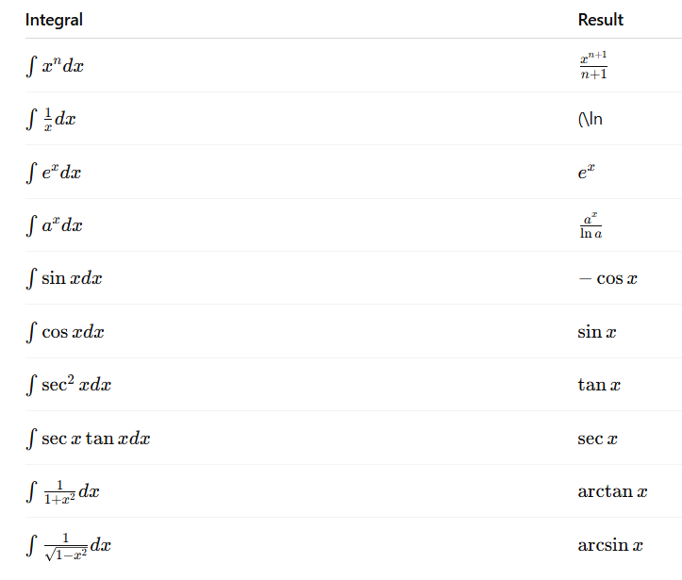

- Algebra skills you should feel comfortable with (bolded frequently show up!)

- Factoring polynomials
- Completing the square
- Long division of polynomials
- Partial fractions No worries if this is new, your teacher should cover it
- Exponent rules See example below
- Logarithm rules
- Solving trig equations
- Unit circle values
- u-substitution from Calc I
- Graphing basic functions
- Working with fractions

The following is an example of an exponent rule that is extremely import to be familiar with, especially when beginning the __ test.

[ex here]

My Advice Going into MATH 1132Q
Calc II is a fast-paced course, and it is a wake-up call. Even as someone with a strong two-year basis in Calc I from high school, Calc II seemed like a major struggle for me at first because it is content-heavy, jumps right into unfamiliar territory, and is intimidating. Here are my three top recommendations about how to be successful in this course:

- Practice, practice, practice. Attend class as often as possible, every little practice problem counts and not practicing consistently will bite you in the butt later on.
- Actually do your homework, for real. Some of the assignments may be difficult and time-consuming, however that struggle is what will drive your success later on. The Cengage problems are often way more difficult than those on exams and quizzes, so if you get through and understand those you will be set. Only use AI help to save time if you are stuck—do NOT abuse it and blow off assignments.
- Find what works best for you. You may not like the way your professor teaches the class, and that is OK—as long as you substitute their teaching adequately. This can be through attending different lectures, utilizing campus resources (like STEM Plus!), or online resources. One that I recommend and used to outline this guide is Dave McArdle’s Calc I & II lecture videos. Keep in mind these are protected via a password, so try reaching out to your professor/Dave if you would like to obtain it.

